Project Proposal has two parts:

1. Problem

1. Introduction

An overall introduction to the documentation (Thesis / proposal) – you will state briefly using a paragraph what the user an expect by reading this document

2. Problem Background / Problem Domain

Why do you need to do a research on this problem – a justification, evidence of existence of the problem, the magnitude of the problem and nature of the problem

This is where you are convincing the examiner / supervisor this problem is worth solving it

3. Problem Definition

State exactly what is the problem you are solving

3.1 Problem Statement

State the problem in nutshell using one sentence

4. Motivation

What motivated you to undertake this research – can be personal reason

5. Existing work

Discuss existing works that are relevant to your research and directly related to the research gap you have picked to resolve in this research project

Between 5 (min) to 10 (max) papers directly related to the research gap you have picked

These existing works are used to justify the gap

|  |  |  |  |
| --- | --- | --- | --- |
| Citation | Brief => about their research in nutshell | Limitation of their research | Contributions of their research |
|  |  |  |  |
|  |  |  |  |
|  |  |  |  |
|  |  |  |  |

6. Research Gap

Just don’t state your research gap but also discuss in detail with justification for selecting those gaps

7. Contribution to the Body of Knowledge

7.1 Contribution to the problem domain

7.2 **Contribution to the research domain**

Note: Justify why these are actually contribution

8. Research Challenge

What is the challenge

Why it is challenging to achieve the identified research gap and make the contribution

9. Research Questions

Maximum of three questions for which you want to find the answer throughout this research

Answering the questions are your research

<https://www.scribbr.com/research-process/research-questions/>

<https://www.scribbr.com/research-process/research-question-examples/>

10. Research Aim

The aim of the research is to design, develop and evaluate <insert whatever you wishes to do>

Justification of the aim can be followed where the aim can be further elaborated

11. Research Objectives

|  |  |  |  |
| --- | --- | --- | --- |
| Research Objectives | Description | Learning Outcomes | Research Questions |
| Literature Review | R01:  R02: | L01, L06 |  |
| Requirement Elicitation | R03:  R04: | L02, L03, L04, L05, L06 |  |
| Design |  | L03, L04, L06 |  |
| Implementation |  | L03, L04, L06 |  |
| Evaluation |  | L04, L06 |  |
|  |  |  |  |
|  |  |  |  |

12. Scope of the Project

12.1 In-scope

12.2 Out-Scope

12.3 A Diagram Depicting the prototype feature

1. Methodology

1. research methodology

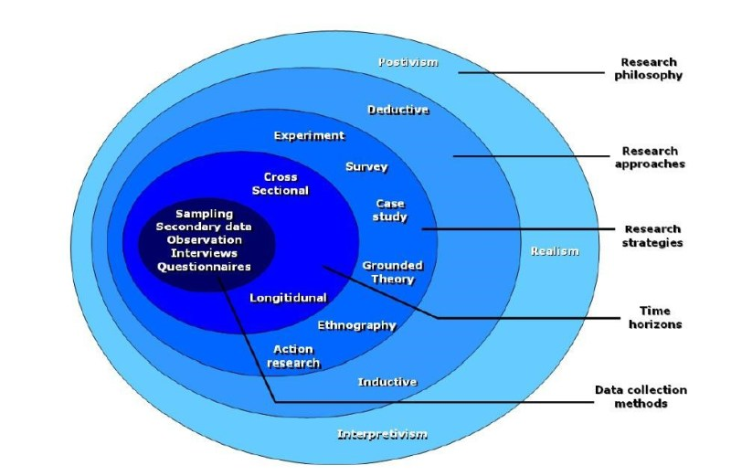

|  |  |  |
| --- | --- | --- |
| Philosophy   1. **Positivism** => if you are planning to do a quantitative research 2. **Interpretivism** => if you are planning to do a qualitative research 3. **Pragmatism** => best of the breeds | What is the philosophy you have chosen | Why do you believe that is the best philosophy for your research |
| Approach   1. **Deductive** => from the theory => hypothesis is built => data collection is done => analysis and prove or disprove the hypothesis => possible theoretical contribution is extension to the theory 2. **Inductive =>** Observation => collection data => analyze the data => build theory |  |  |
| Strategy:   1. Questionnaire (Survey):  * Qualitative * Quantitative * Mixed (used only by pragmatist)  1. Interviews  * Structured interview (based on a theme) * Semi structured * Unstructured  1. Experiments  * Obtain result by applying various metrics  1. Literature 2. Observation 3. Brainstorming 4. Focus group testing (applicable for evaluation of your prototype/MVP) |  |  |
| Choice:   1. Mono method => only one method to be used to collect data 2. Multi method => more than one method but all belongs to same paradigm (Functionalist (Quan)/interpretivist(qual)) 3. Mixed method => one from functionalist paradigm and one from interpretivist (you are mixing the method => only possible when you choose pragmatism) |  |  |
| Time horizon   1. Cross sectional – once in time frame 2. Longitudinal – data collected and linked in two different time frames |  |  |
| Sample size  >= 100 can use questionnaire  < 100 can use interviews in that case 5 to 30 interview |  |  |
|  |  |  |
|  |  |  |
|  |  |  |

2. Development methodology

2.1 What is the development methodology

1. **prototyping**

2. one person agile methodology

2.2. Requirement elicitation methodology

a) survey

- interview

- questionnaire

b) literature review

c) experiment

d) observation

e) brainstorming

…

* 1. Design methodology

1. OOAD
2. SSADM
   1. Development methodology
      1. OOP
      2. Structured Programming
      3. Functional Programming
   2. Testing methodology => how are you intend to test
3. Prototype testing
4. Model testing (evaluation metrics)
5. Benchmarking
   1. **Solution methodology**
6. Project management methodology
   1. What is the project management methodology
7. Prince 2
8. Agile Prince 2
   1. Schedule

W.B. S (never part of the project proposal but needed to find the activities so you can come up with detailed activity chart)

Activity chart (never part of your project proposal => Gantt chart can only be drawn if you have an activity chart)

* + 1. Gantt chart (This is part of the project proposal => don’t make it like waterfall pls)
    2. Deliverables and dates
  1. Resource requirements
     1. Software resources
     2. Hardware resources
     3. Data requirements (if it is data science project)
     4. Skill requirements
  2. Risk and mitigation

Identify and prioritize most 5 risks you might face in completing this project on time

|  |  |  |  |
| --- | --- | --- | --- |
| Risk | Probability of Occurrence | Magnitude of the loss | Mitigation Plan |
| Not enough time to learn required know how and acquire the skills | 5 | 5 |  |
| Getting sick |  |  |  |
|  |  |  |  |
|  |  |  |  |
|  |  |  |  |
|  |  |  |  |
|  |  |  |  |

**Page count 20 to 25 not more than that**

**Note:- if the page count goes above penalty will be applied**